LEP - Learn English Podcast

https://www.youtube.com/@LEP-LearnEnglishPodcast
Hi there!
In order to edit our document for your class, go to
File → Make a copy
You can edit your copy!
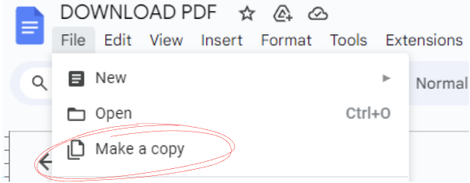

Or if you want to download, go to

File → Download
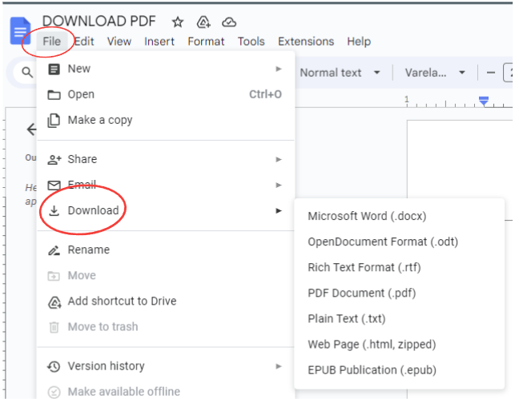
- The end -


Transcripts
Nathan: Hi everyone! Welcome back to 8 Minute English on the Learn English Podcast channel.
Nathan: So, how’s everyone feeling today? With this cold weather, I bet some of you might be sneezing or even dealing with a cold.
Nathan: Are you one of them? Don’t worry—today’s episode might just have the answers you’re looking for.
Nathan: Have you ever wondered, “Why do I get sick so easily?” Or maybe you’ve noticed that you’re always the first one to catch a cold in your family or at work?
Nathan: Well, today we’re diving into this topic: Why do you get sick easily?
Nathan: And, as always, don’t forget to check out the free PDF with all the tips and vocabulary from this episode—it’s in the description below!
Nathan: Ready to find out what’s making you feel tired or sick? Let’s get started!
Liam: Hey Mia, you don’t look so great today. Is everything alright?
Mia: Not really. I’ve been feeling tired and keep sneezing all the time.
Rachel: That doesn’t sound good. You might be catching a cold. Do you think it could be because of a weak immune system?
Liam: Hmm, now that you mention it, I’ve been getting sick a lot lately—like colds and stomach bugs.
Rachel: That’s a sign, Mia. A weak immune system doesn’t just make you catch colds. It can also make infections last longer.
Liam: Right. And it’s not just colds. Did you know that with a weak immune system, even small cuts or wounds can take longer to heal?
Mia: Really? I didn’t realize it could affect so much.
Rachel: Absolutely. It also increases your risk of more serious infections. For example, a weak immune system can make something like the flu turn into pneumonia if you’re not careful.
Liam: And it doesn’t stop there. A weak immune system can even lead to fatigue and make you feel tired all the time.
Mia: That explains a lot. I’ve been feeling tired even after sleeping for 8 hours.
Rachel: And it can also affect your ability to fight off stress. Chronic stress weakens your immune system even more, creating a vicious cycle.
Mia: So, stress makes my immune system weaker, and then I get sick, which makes me more stressed?
Rachel: Exactly. That’s why it’s so important to strengthen your immune system. Small changes, like sleeping better, eating nutritious food, and managing stress, can help break the cycle.
Mia: Ah! And I haven’t been sleeping well lately. I stay up late watching shows, and I always feel drained the next day.
Liam: Lack of sleep is definitely a big problem. Did you know that when you don’t sleep enough, your body makes fewer immune cells?
Mia: Really? I didn’t know that. So, just sleeping better can make me healthier?
Rachel: Exactly. Aim for 7-8 hours of sleep every night, and you’ll feel much better.
Liam: And what about your diet? Are you eating nutritious meals?
Mia: Honestly, no. I’ve been eating a lot of takeout and skipping fruits and veggies.
Rachel: That could be another reason why you’re feeling this way. Foods rich in vitamin C and D are great for keeping your immune system strong.
Liam: Exactly. Add things like oranges, broccoli, and salmon to your meals. They’re packed with nutrients that fight off illness.
Mia: Hmm… I guess my diet does need some fixing. But I also feel so stressed out lately. Could that be a factor too?
Rachel: Absolutely. Chronic stress weakens your immune system over time, making it harder for your body to fight off infections.
Mia: So, what can I do to manage stress?
Liam: Try doing yoga or meditating. Even taking a short walk outside can help you relax and feel more balanced.
Mia: I’ll try that. Oh, and I work in a shared office space. Could germs from others be a problem?
Rachel: Definitely. Places with lots of people can expose you to more germs. Make sure to wash your hands often and avoid touching your face.
Mia: That’s good advice. I’ll start being more careful about that. Also, I don’t drink enough water. Could that be part of the problem?
Liam: Yes! Dehydration makes it harder for your body to flush out toxins and can leave you feeling sluggish.
Rachel: Try drinking at least 8 glasses of water a day. It’ll help your body function better and keep you energized.
Liam: And don’t forget to stay active. Sitting all day can lower your energy levels and make your immune system weaker over time.
Mia: Thanks, guys. I feel like I’ve learned so much already.
Rachel: Anytime, Mia. Just remember, small changes can make a big difference.
Liam: Let us know how it goes!
Nathan: Let’s go over some useful phrases from today’s discussion!
Nathan: 1. Catch a cold: To become sick with a common illness, especially in colder weather.
Example: If you don’t wear a jacket, you might catch a cold in this weather.
Nathan: 2. Build resistance: To strengthen your body’s ability to fight illnesses.
Example: Regular exercise can help you build resistance against common colds.
Nathan: 3. Break a habit: To stop doing something that’s not good for you.
Example: I’m trying to break the habit of staying up too late.
Nathan: 4. Take precautions: To take steps to prevent something bad from happening.
Example: Washing your hands regularly is a good way to take precautions against germs.
Nathan: 5. Stay active: To keep moving and exercising to maintain good health.
Example: Even a 10-minute walk can help you stay active and energized.
Nathan: Now, here’s something to think about!
Nathan: Question 1: What’s one change you could make to avoid getting sick during colder months?
For me, wearing layers and staying hydrated have been game-changers.
Nathan: Question 2: How do you stay active when you don’t feel like exercising?
For me, short stretches or dancing to my favorite music really helps. What about you?
Nathan: Don’t forget to share your tips below—we’d love to know what works for you!
Nathan: Before we wrap up, let me share some fun facts and research about staying healthy!
Nathan: Did you know that laughing can boost your immune system?
A study from Loma Linda University found that laughing reduces stress and increases the production of immune cells in your body.
Nathan: So, next time you feel down, watch a funny video or share a joke with friends—it’s good for your health!
Nathan: Here’s another interesting fact: Staying hydrated can improve your focus by up to 14%!
According to the University of Connecticut, even mild dehydration can affect your mood and cognitive abilities.
Nathan: So, keep a bottle of water handy and take regular sips throughout the day.
Nathan: Oh, and here’s something fascinating about sleep: A study from Harvard Medical School shows that sleeping 7-9 hours a night helps your brain store new information.
That means getting enough rest can make you smarter and healthier!
Nathan: Don’t forget, we’ve put together a free PDF with all these tips and more—it’s in the description or comments below.
Make sure to check it out and let us know if you found it helpful!
Nathan: That’s it for today’s episode of 8 Minute English.
Thank you for joining me, and I hope you learned something new and useful!
Nathan: Take care, stay healthy, and I’ll see you in the next episode.

Vocabulary

Vocabulary | Transcription | Definition | Example
Catch a cold | /kætʃ ə koʊld/ | To become sick with a common illness, especially in colder weather. | "If you don’t wear a jacket, you might catch a cold in this weather."
Weak immune system | /wiːk ɪˈmjuːn ˈsɪstəm/ | When the body’s defense system is not strong enough to fight off infections. | "A weak immune system makes it easier to get sick."
Build resistance | /bɪld rɪˈzɪstəns/ | To strengthen your body’s ability to fight illnesses. | "Eating nutritious food can help you build resistance to colds."
Chronic stress | /ˈkrɒnɪk strɛs/ | Long-term stress that can negatively affect health. | "Chronic stress weakens your immune system over time."
Take precautions | /teɪk prɪˈkɔːʃənz/ | To take steps to prevent something bad from happening. | "Washing your hands regularly is a good way to take precautions against germs."
Dehydration | /diːhaɪˈdreɪʃən/ | A condition where the body lacks enough water to function properly. | "Dehydration can make you feel tired and sluggish."
Nutritious | /njuːˈtrɪʃəs/ | Containing the nutrients needed for good health. | "Adding nutritious foods like fruits and vegetables to your diet is essential."
Fatigue | /fəˈtiːg/ | Extreme tiredness or lack of energy. | "Fatigue is a common sign of a weak immune system."
Flush out | /flʌʃ aʊt/ | To remove unwanted substances from the body. | "Drinking water helps flush out toxins from your body."
Stay active | /steɪ ˈæktɪv/ | To keep moving and exercising to maintain good health. | "Even a short walk can help you stay active and feel  energized."

Pre-Listen Questions
- How do you usually protect yourself from getting sick?
- What foods do you eat to stay healthy during cold weather?
- Have you ever experienced feeling constantly tired? What caused it?
- What do you know about building a strong immune system?
- Do you think stress affects your health? Why or why not?

Coherence Questions
- What are some effects of a weak immune system mentioned in the podcast?
- How does lack of sleep weaken your immune system?
- What foods can help strengthen your immune system?
- Why is drinking water important for staying healthy?
- How does chronic stress create a cycle of poor health?
- What are some practical ways to manage stress?
- How can working in a shared space increase the risk of getting sick?
- What simple habits can help you avoid getting sick?
- Why is staying active important for your immune system?
- What are the benefits of laughing for your health?

Post-Listen Questions
- Which tip from the podcast would you try to strengthen your immune system?
- How can you include more nutritious foods in your daily diet?
- What changes can you make to improve your sleep routine?
- How would you manage stress better after listening to the podcast?
- What small steps can you take today to avoid getting sick?
4o

